**Database Technologies – UE20CS343**

**Assignment – 2**

**Name**: Vishwa Mehul Mehta

**SRN**: PES2UG20CS389

**Sec**: F

**Date**: 19-03-2023

**Random Value Insertions:**

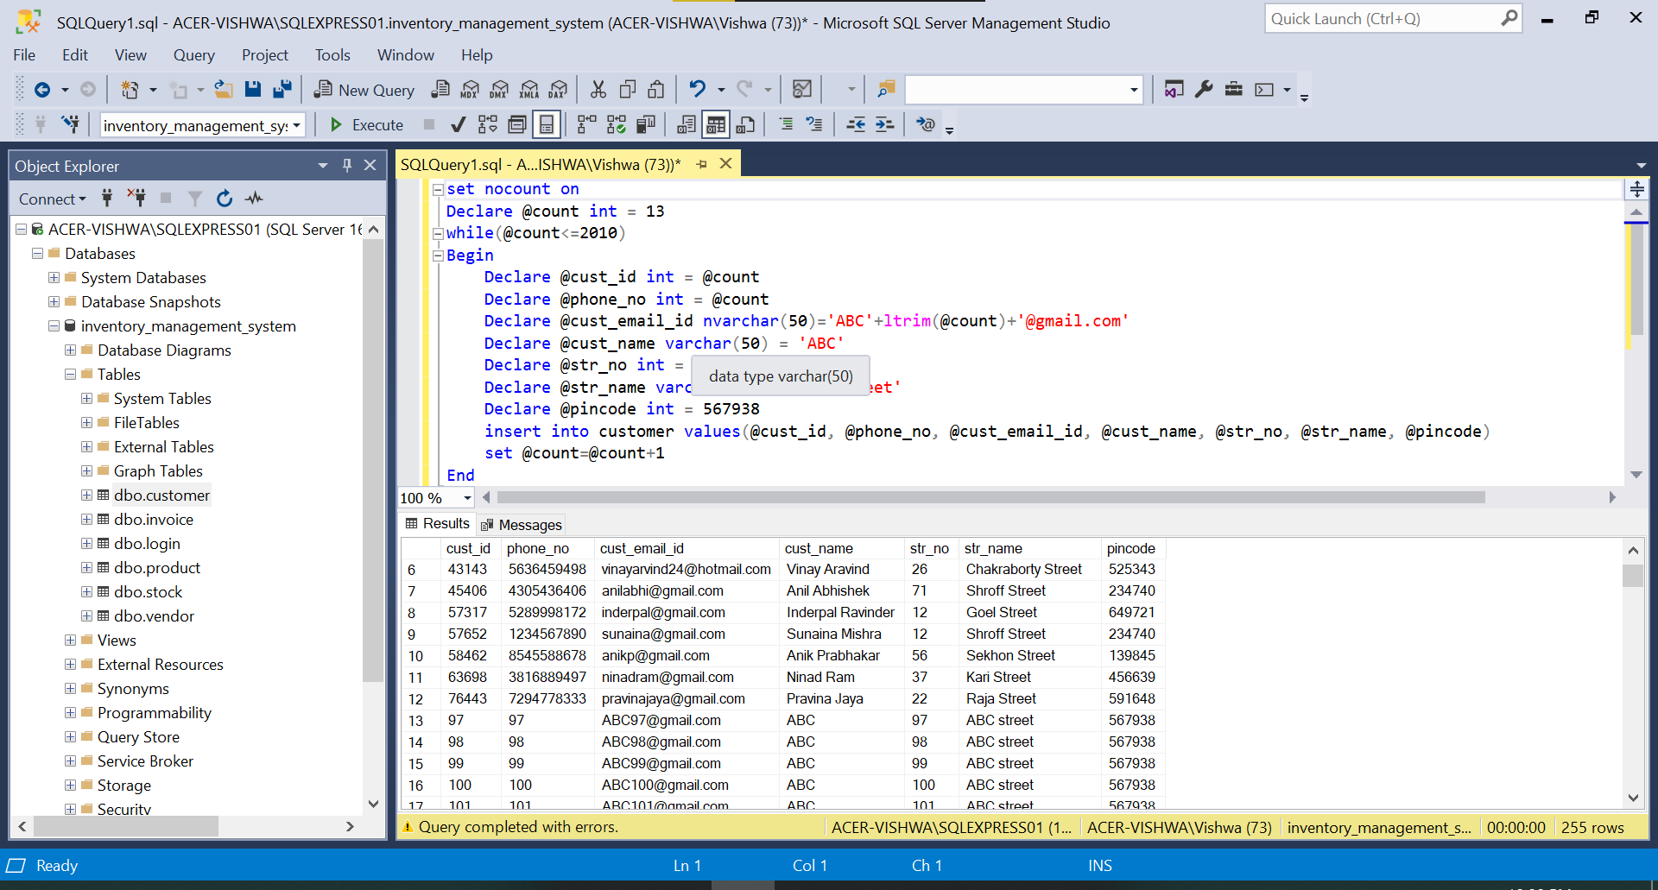

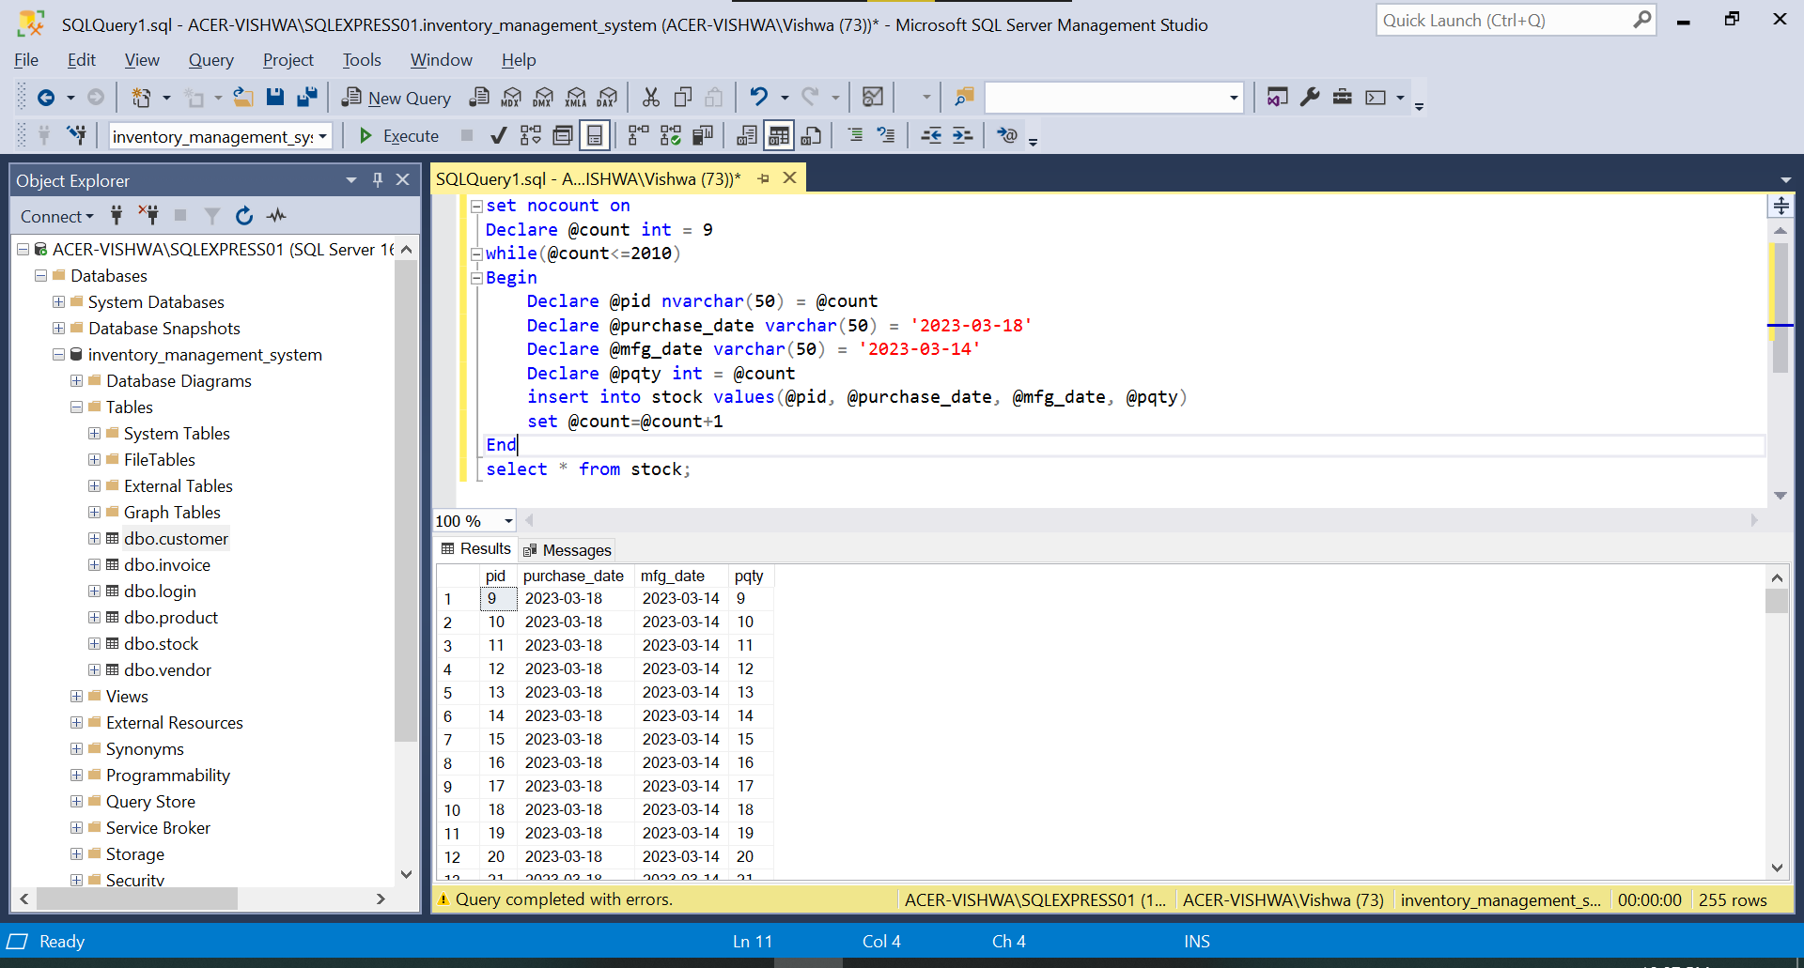

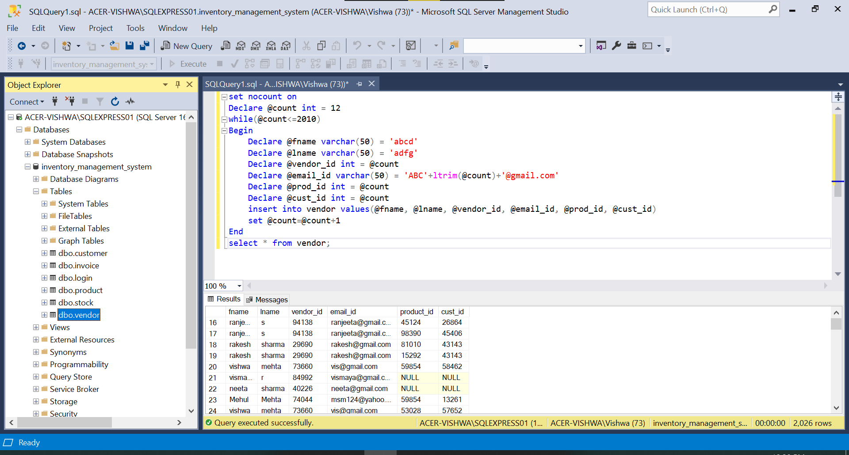

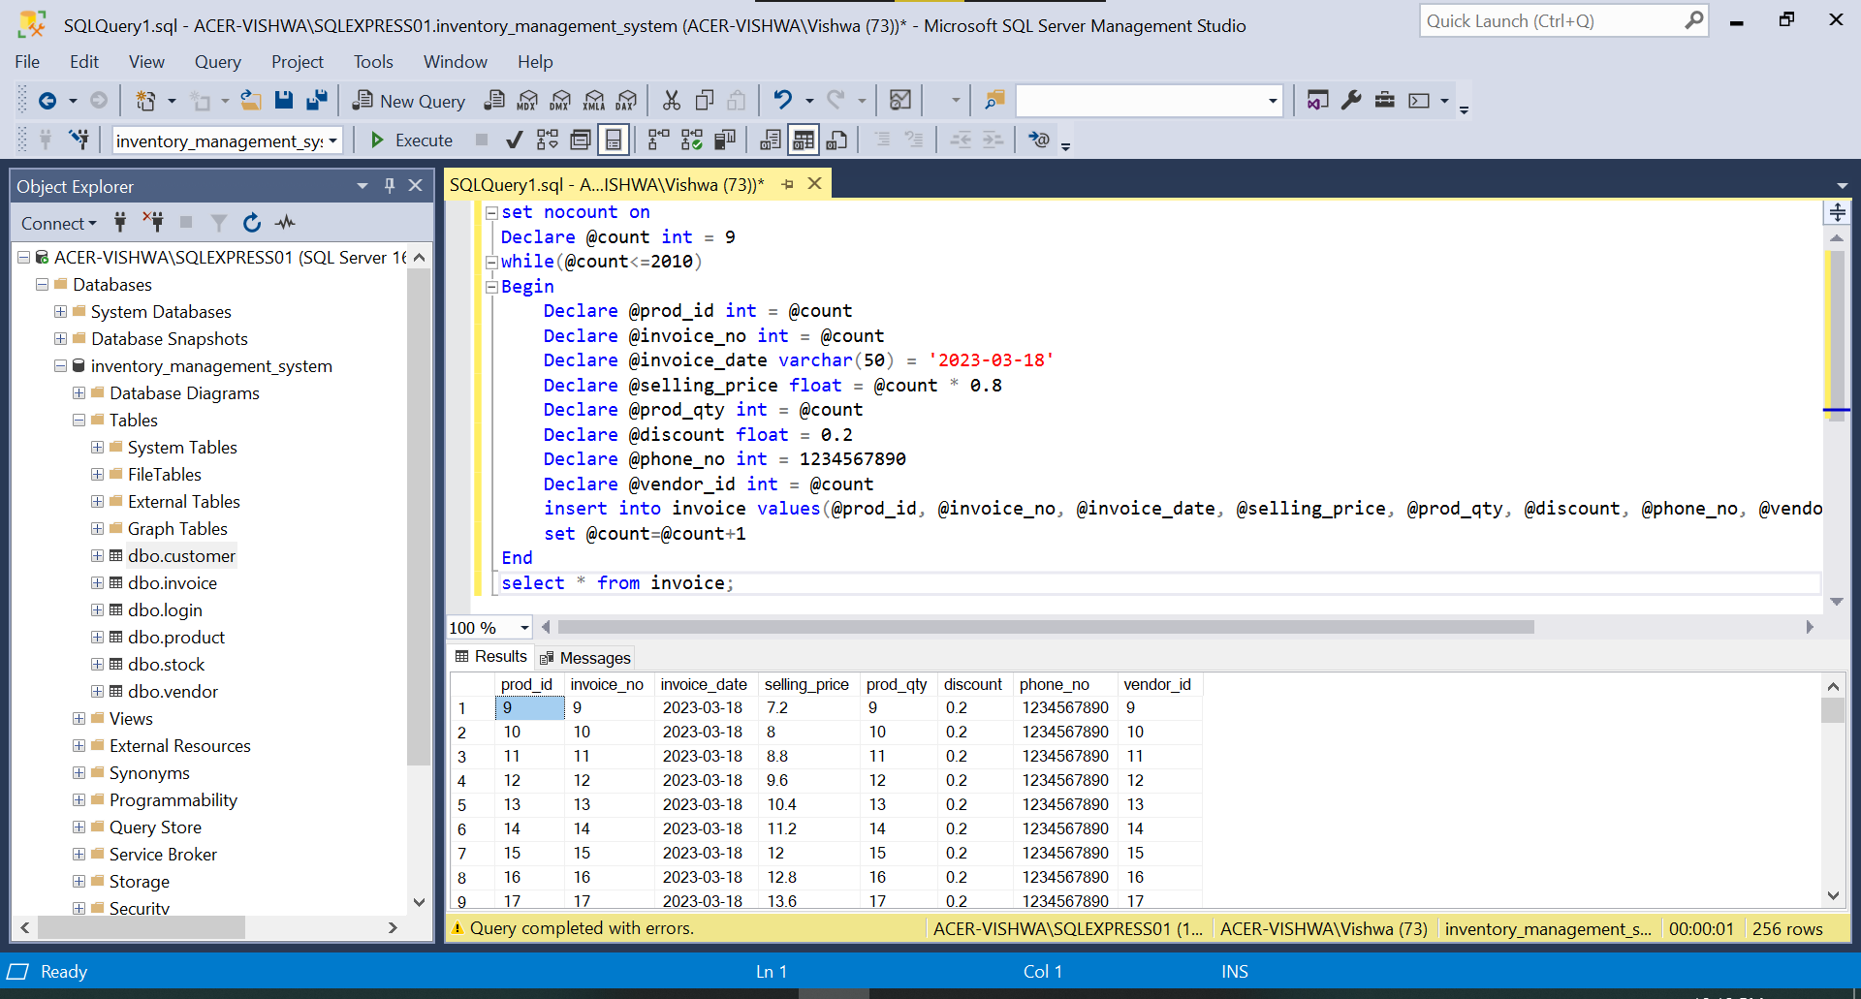

**(a) Task 1:**

1.

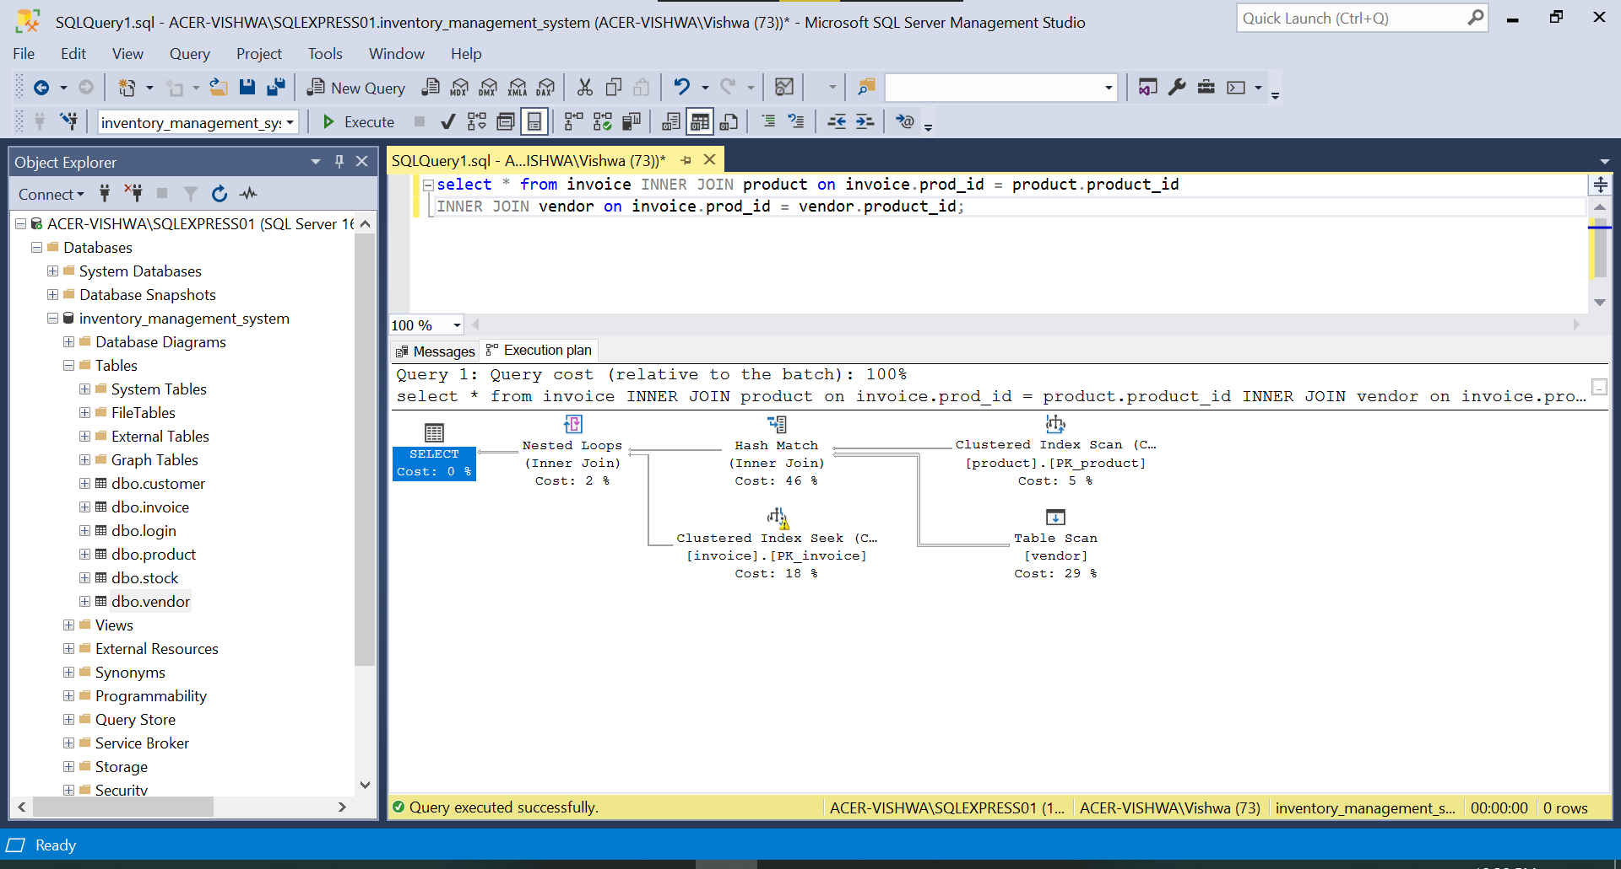

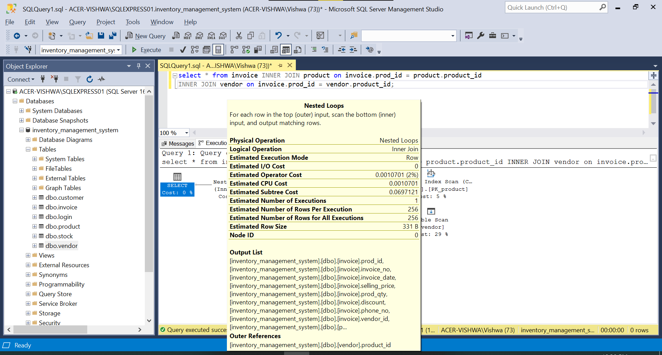

2.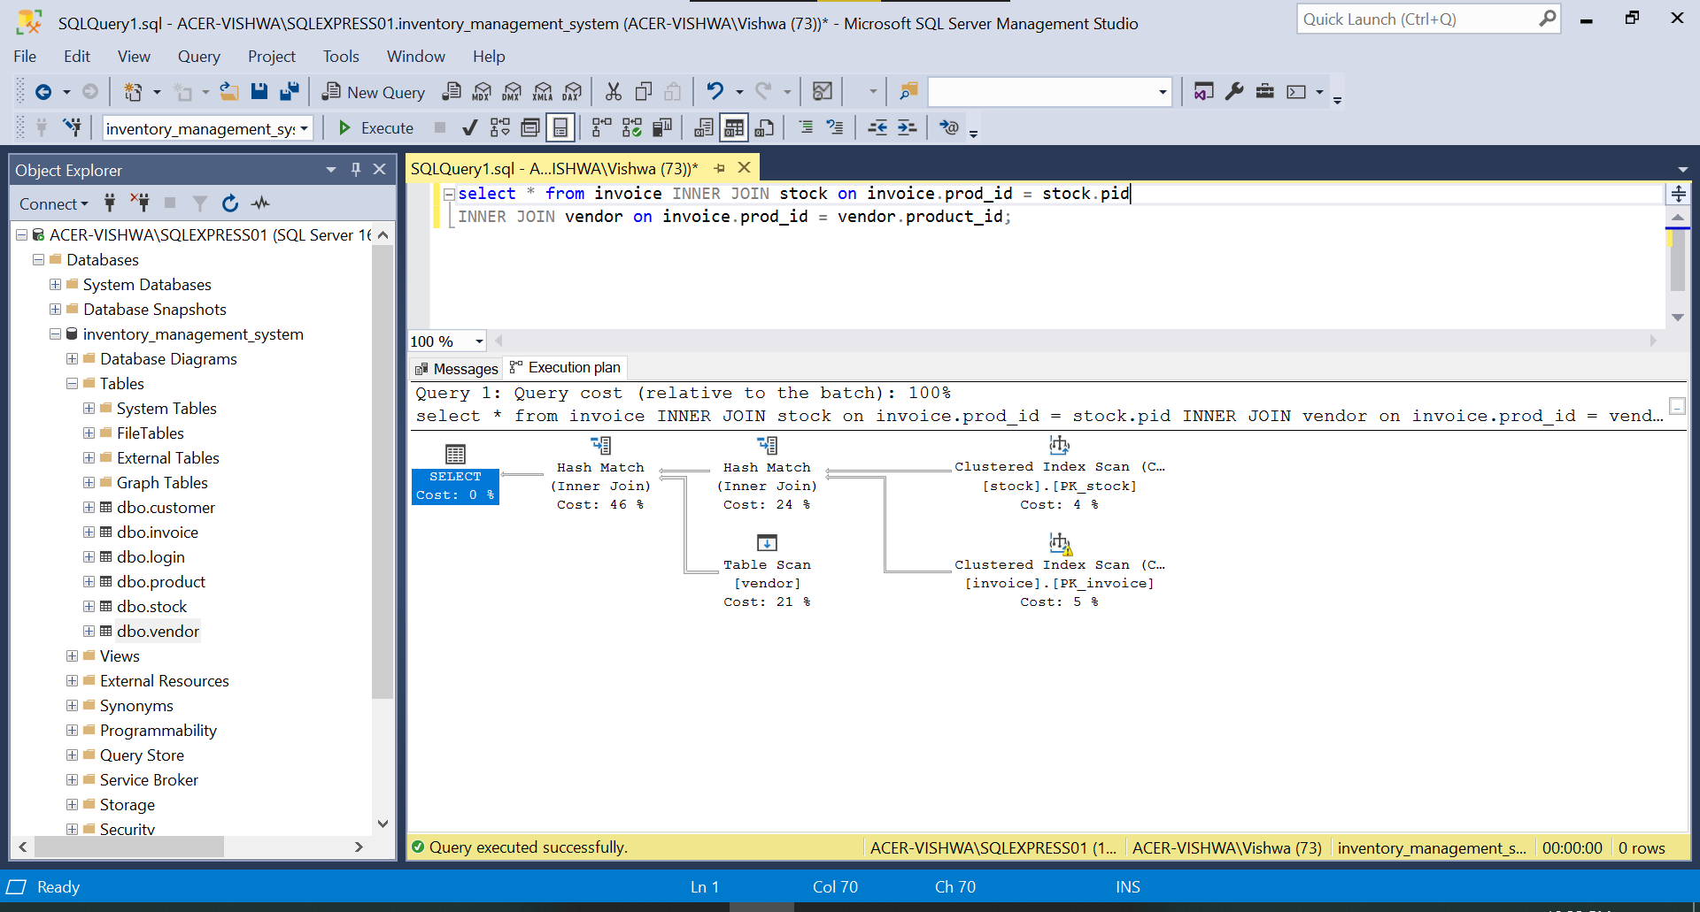

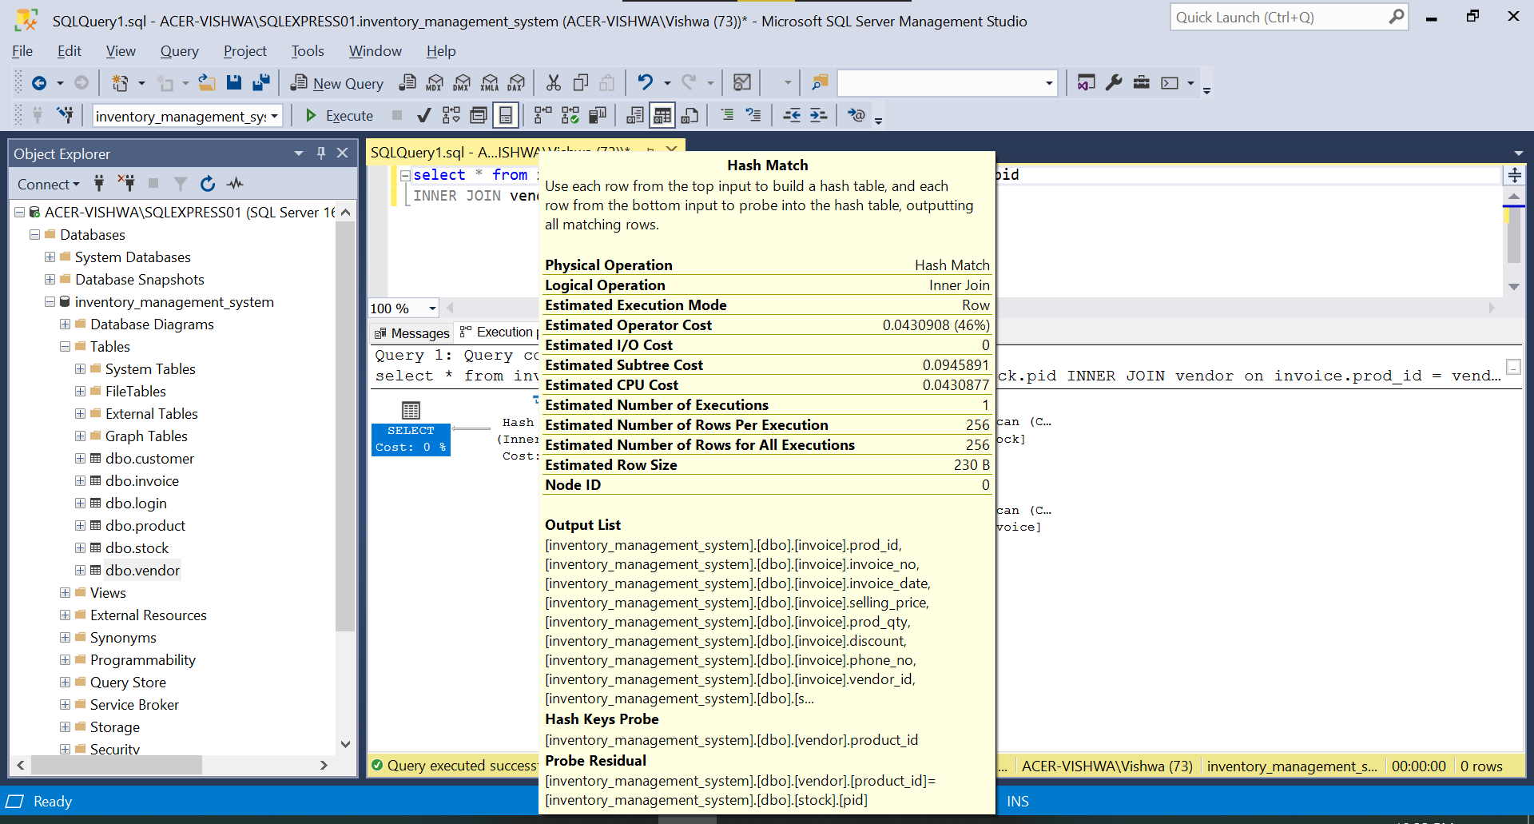

**(b) Task 2:**

1. LEFT OUTER JOIN – invoice, stock, vendor

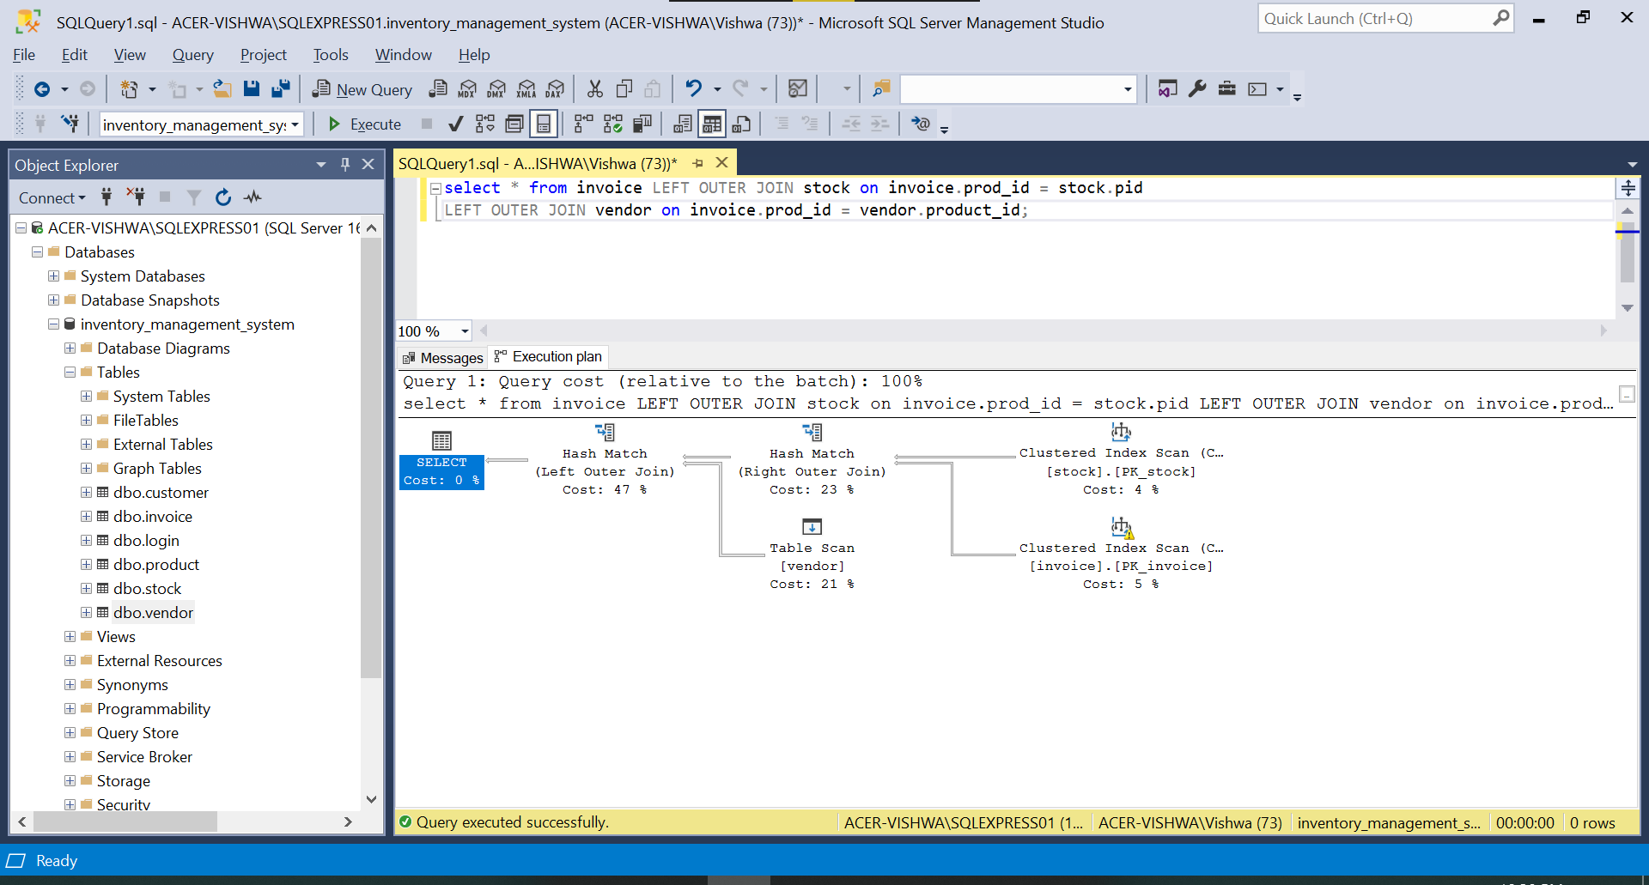

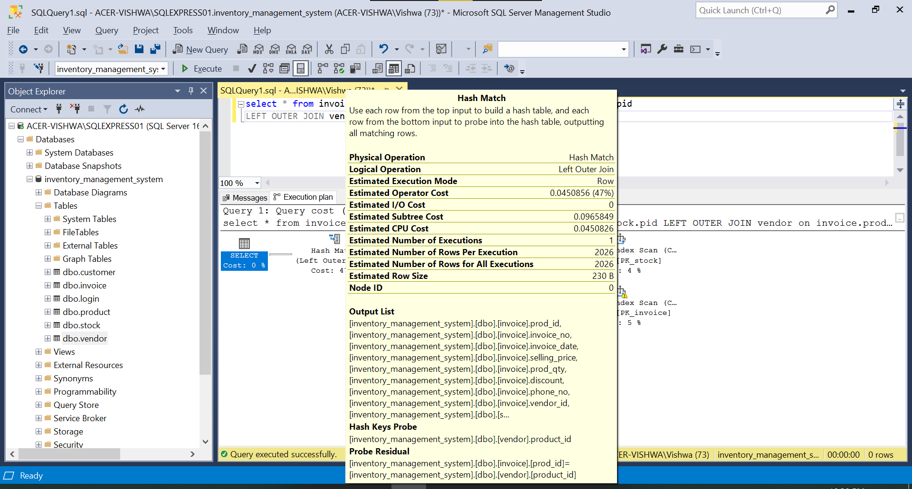

2. LEFT OUTER JOIN – vendor, invoice, stock

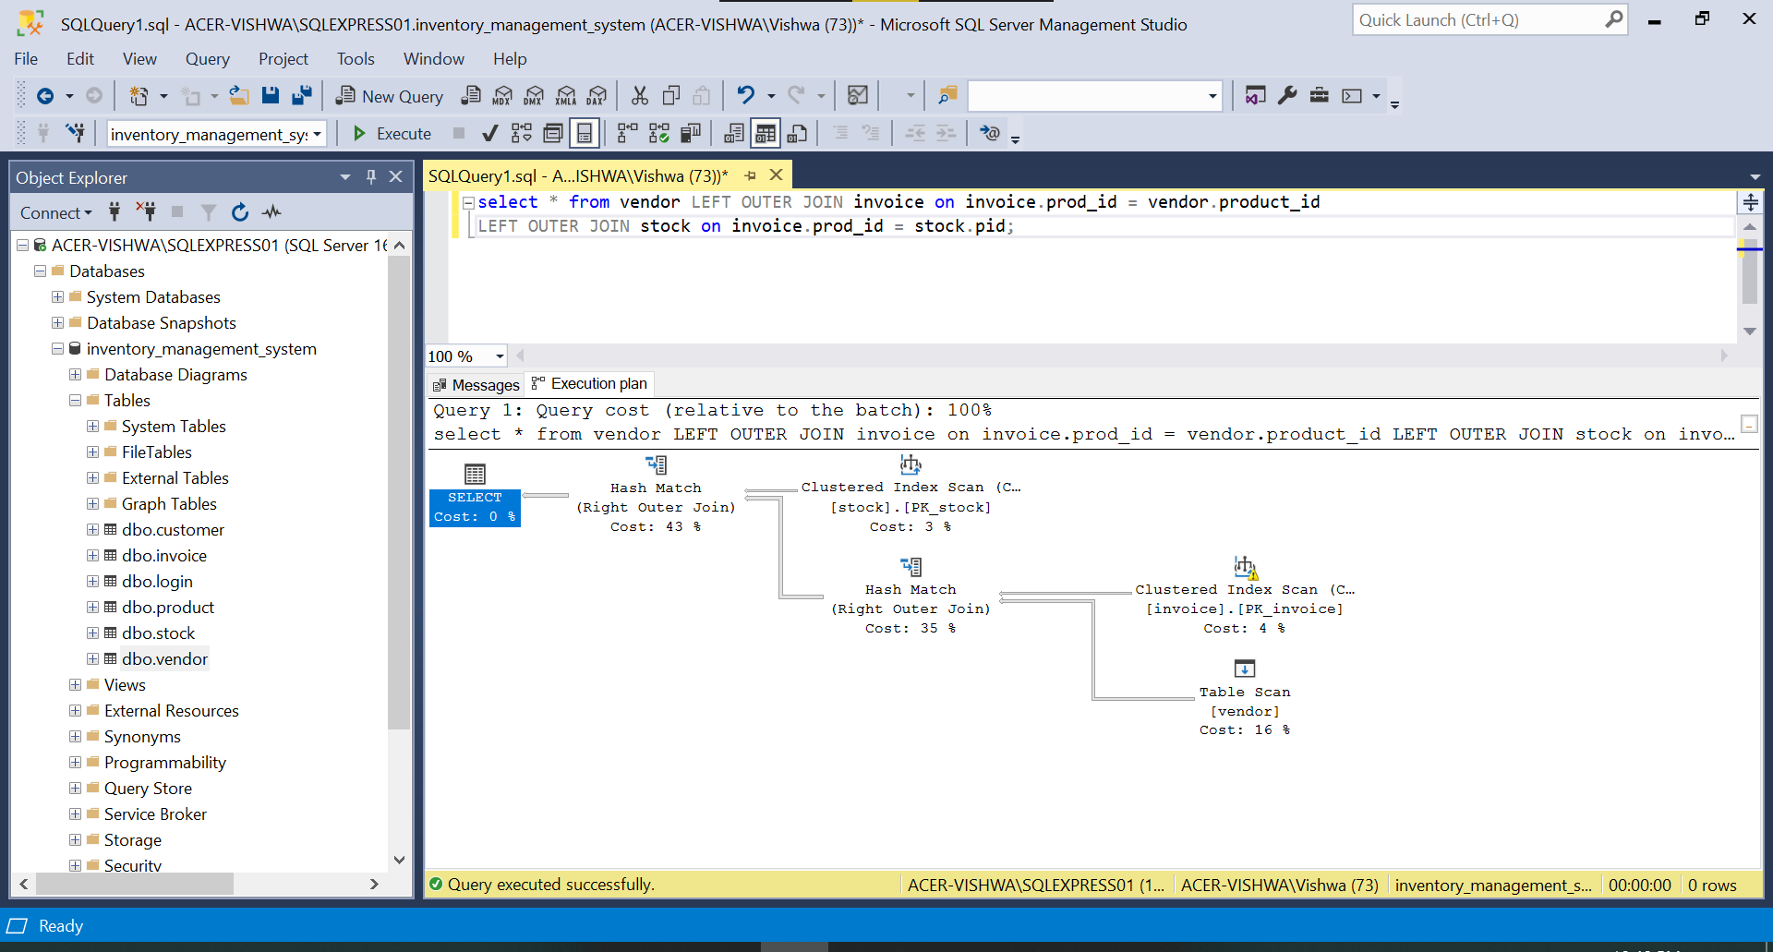

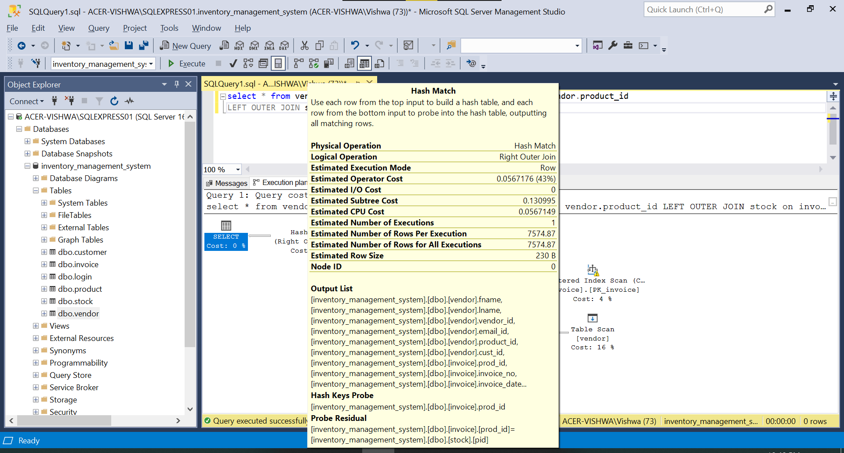

3. RIGHT OUTER JOIN – vendor, invoice, stock

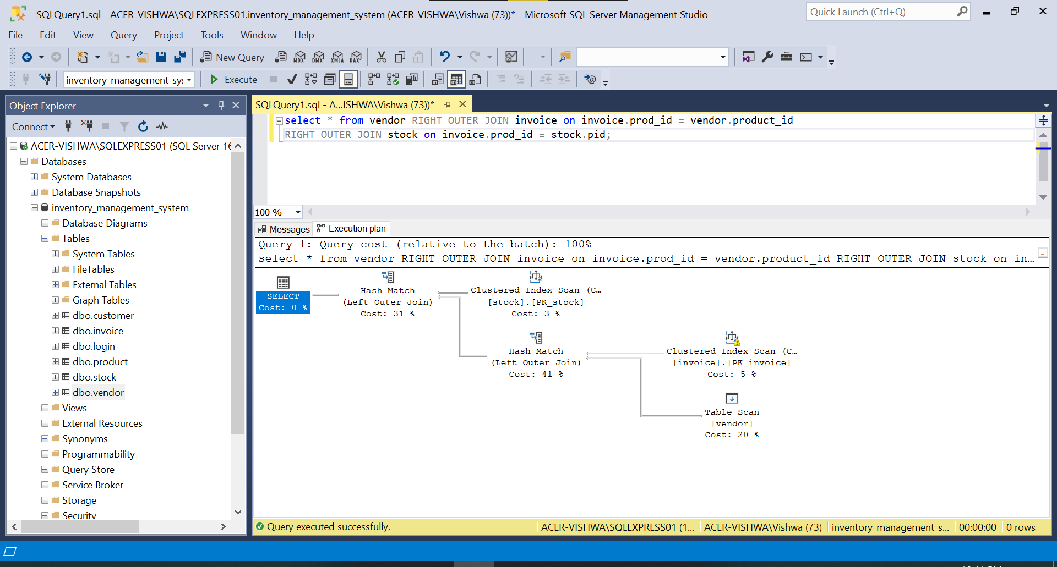

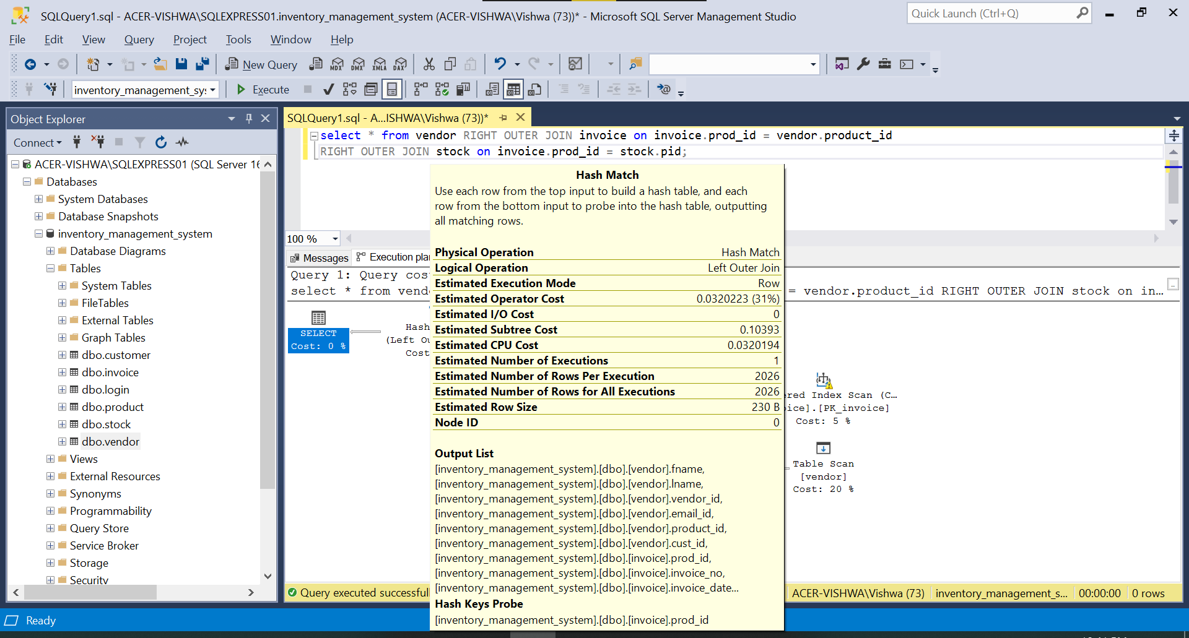

4. RIGHT OUTER JOIN – invoice, stock, vendor

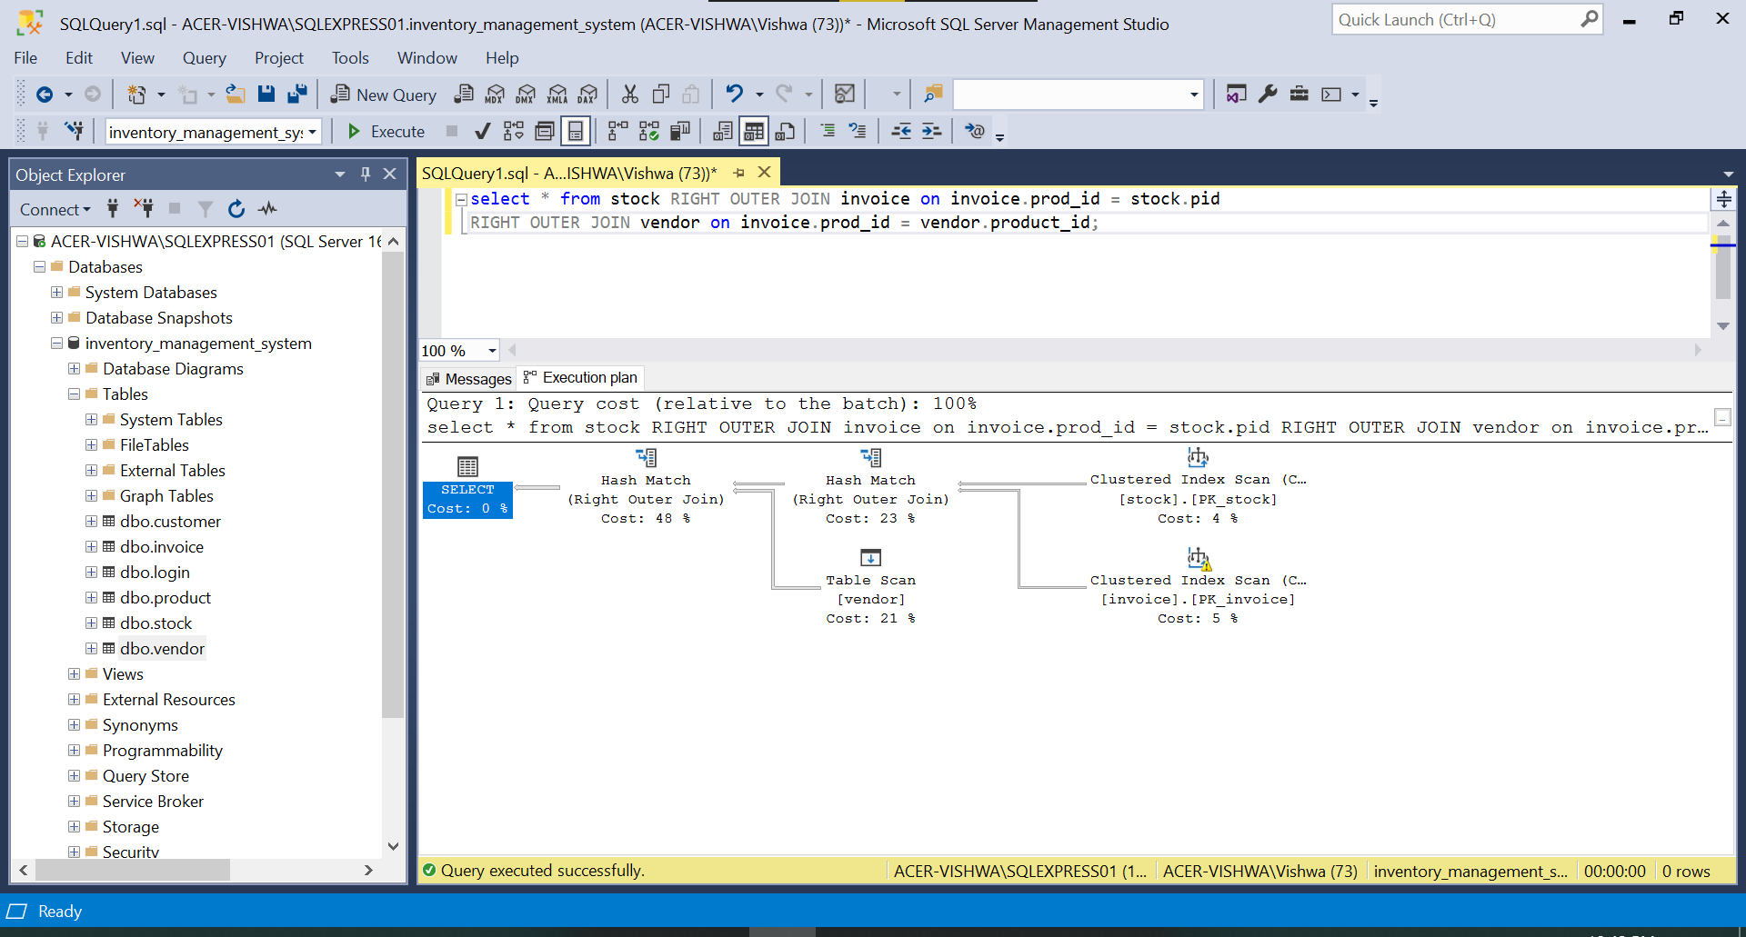

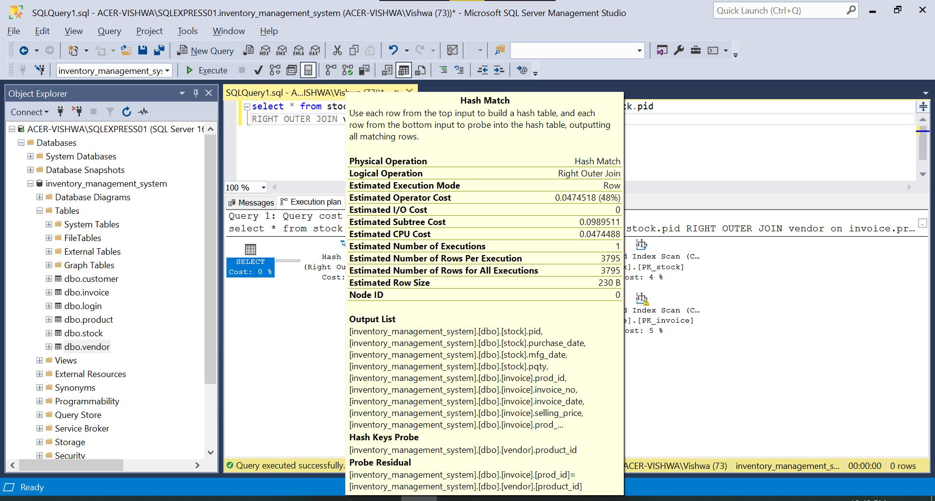

5. SUB QUERIES – stock, invoice, vendor

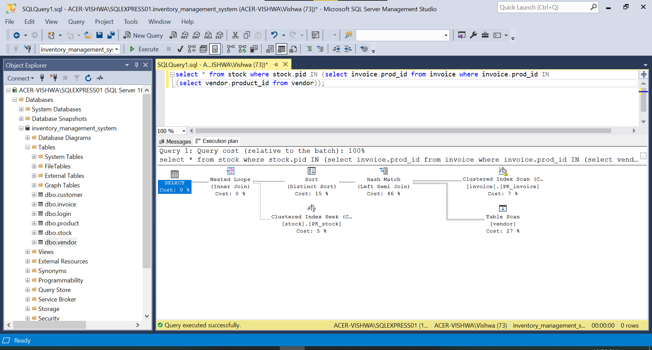

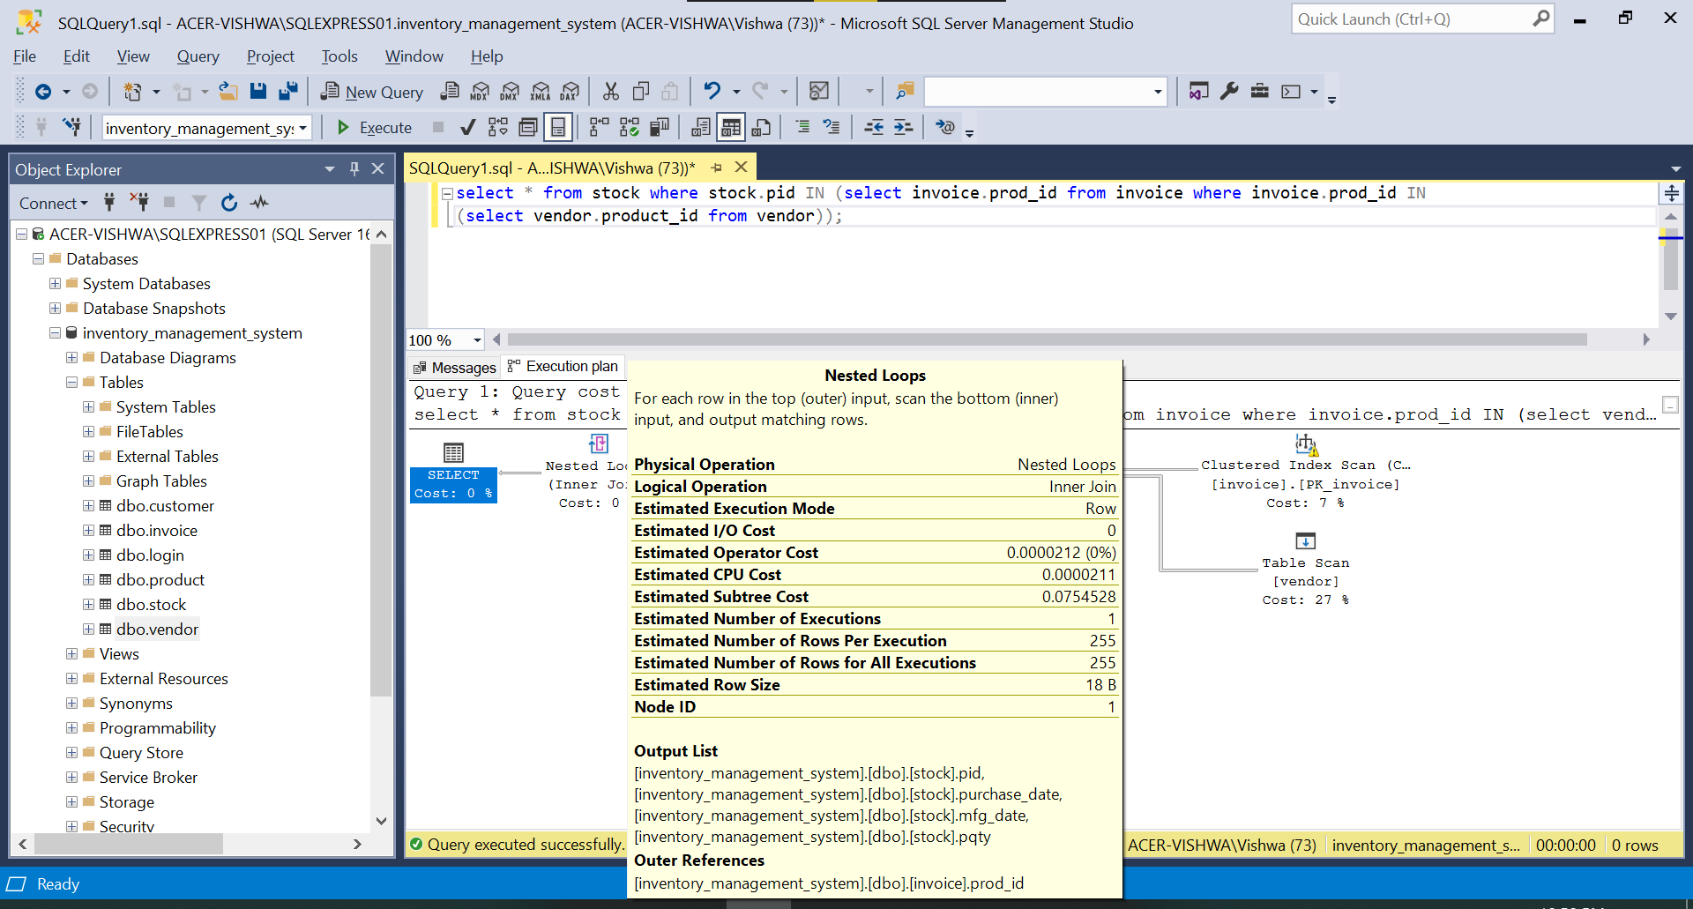

6. SUB QUERIES – stock, vendor, invoice

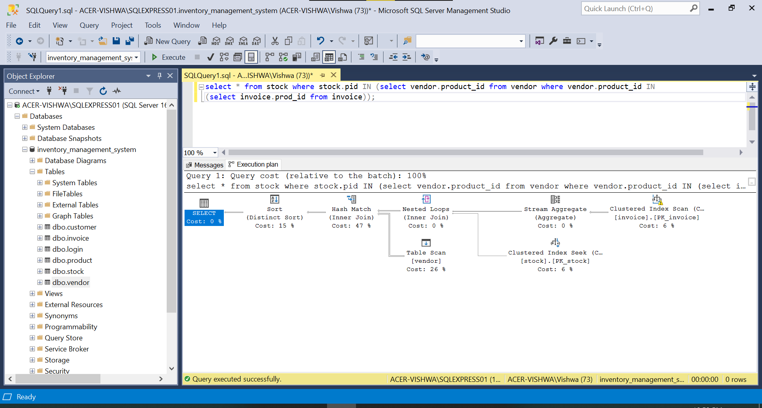

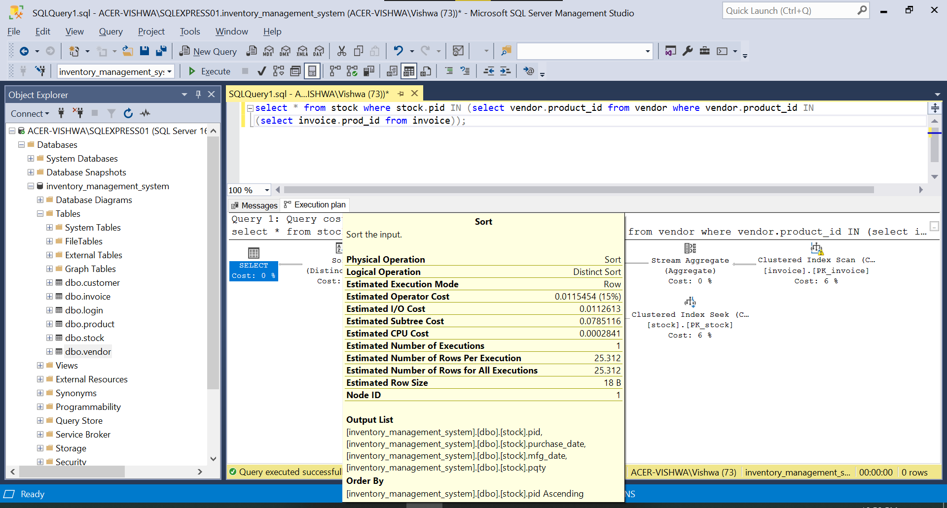

7. LEFT OUTER JOIN – invoice, product, vendor

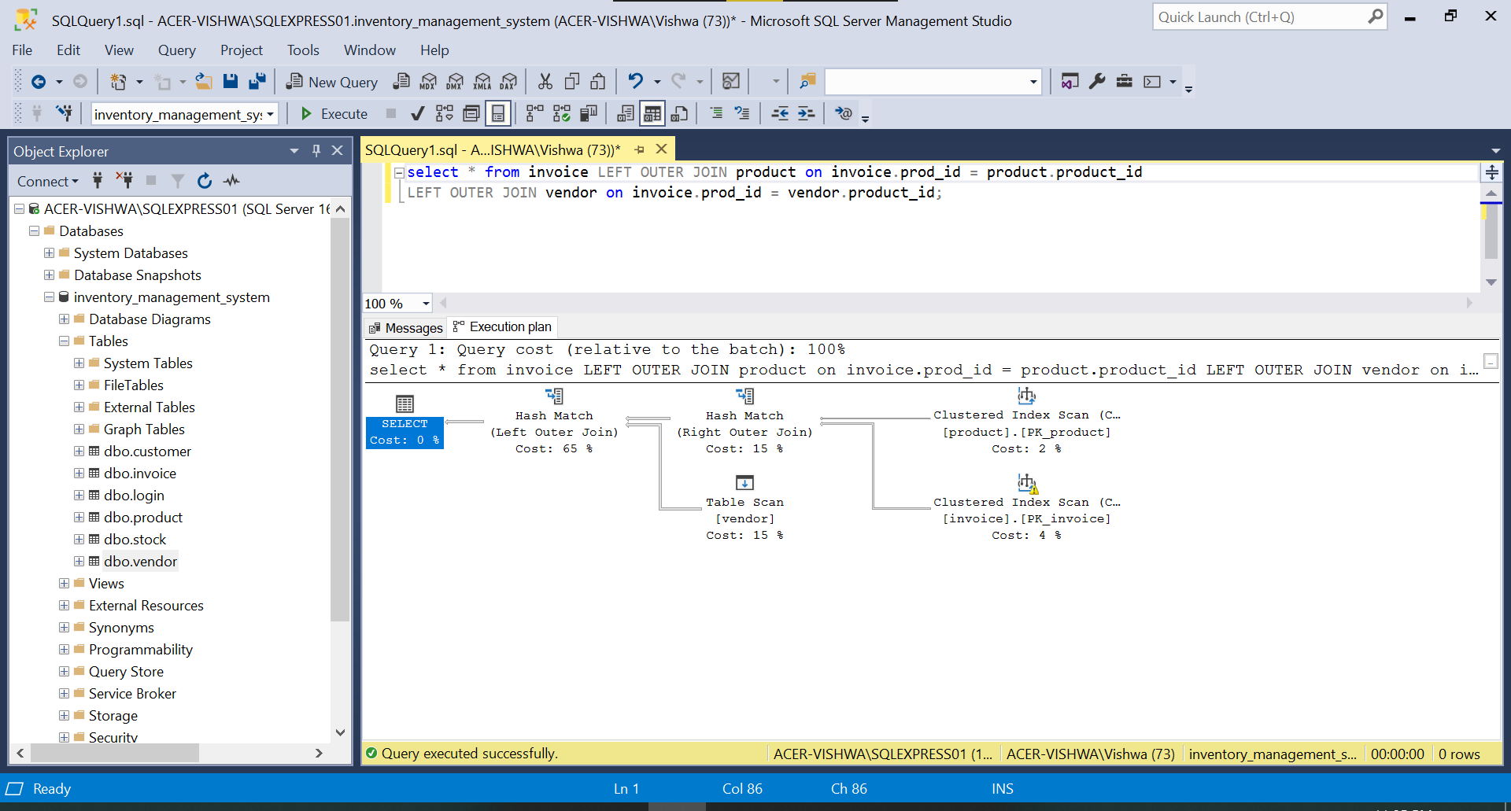

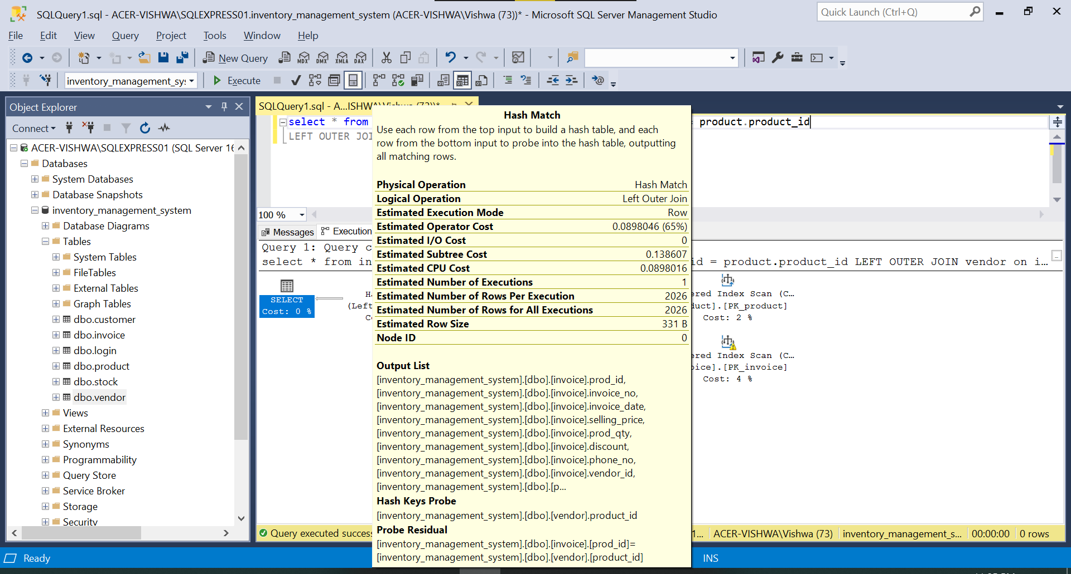

8. LEFT OUTER JOIN – vendor, invoice, product

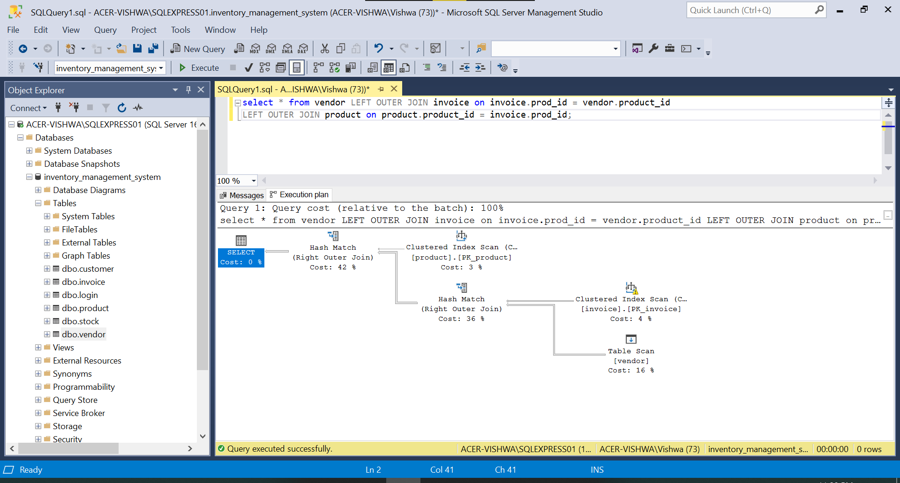

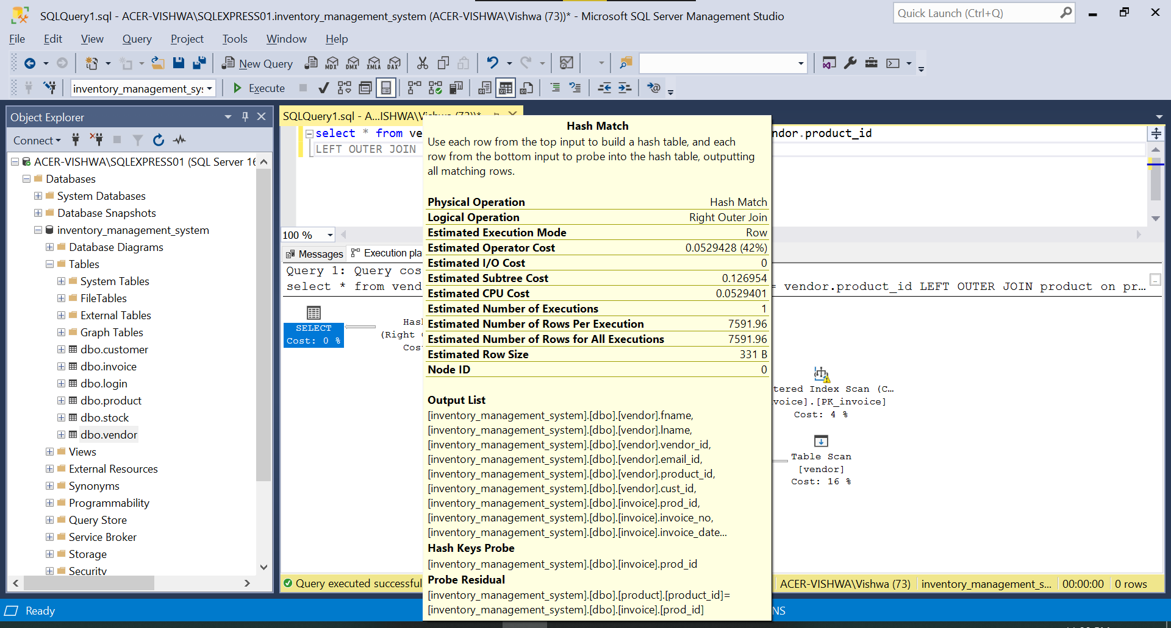

9. RIGHT OUTER JOIN – vendor, invoice, product

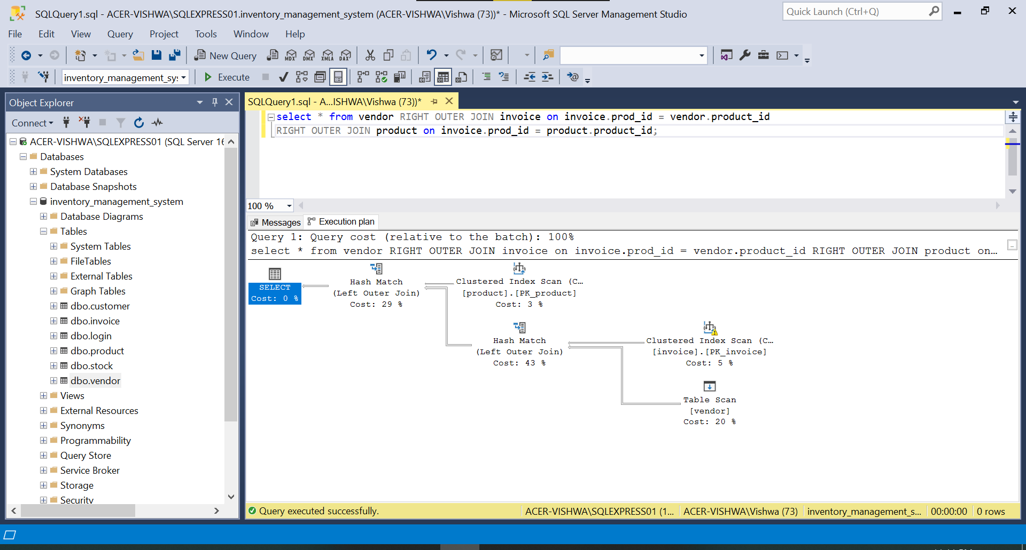

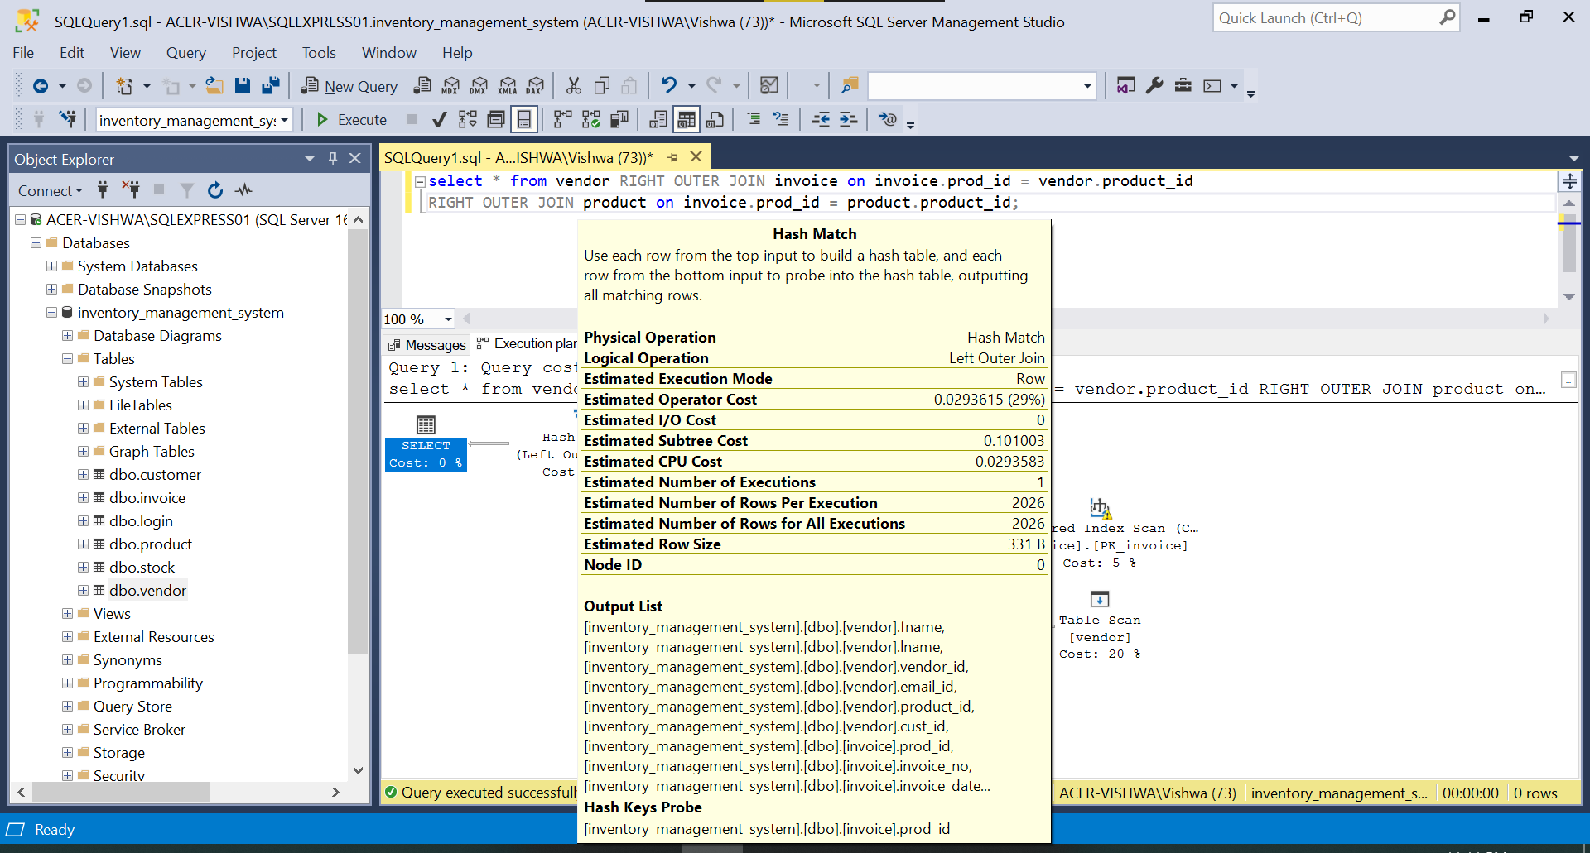

10. RIGHT OUTER JOIN – invoice, product, vendor

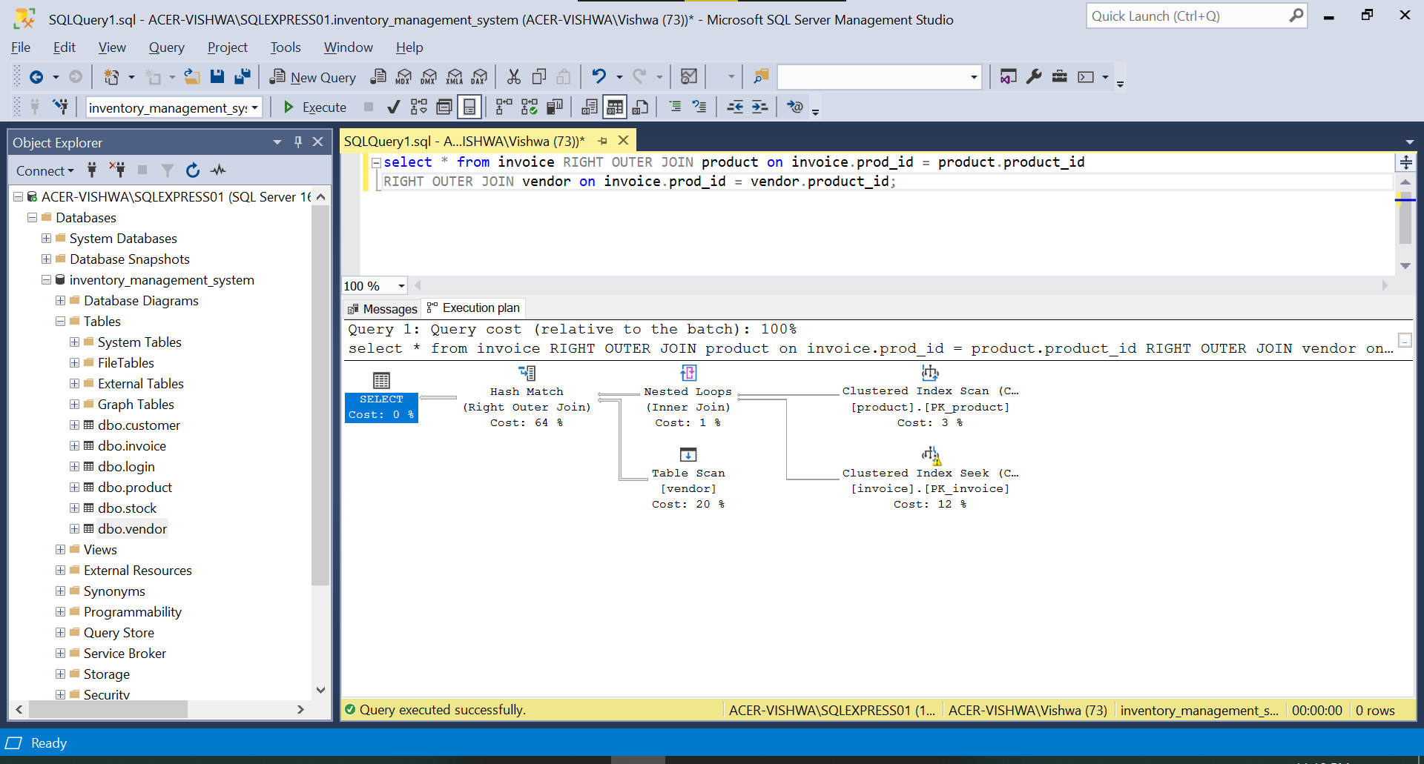

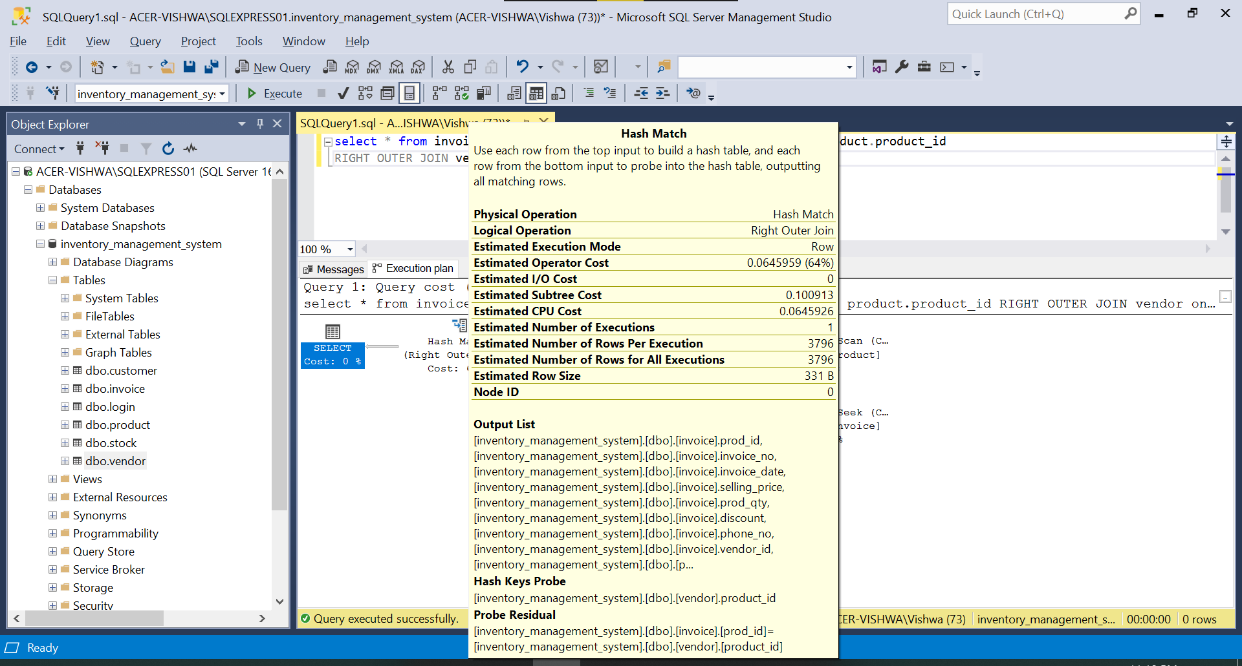

11. SUB QUERIES – product, invoice, vendor

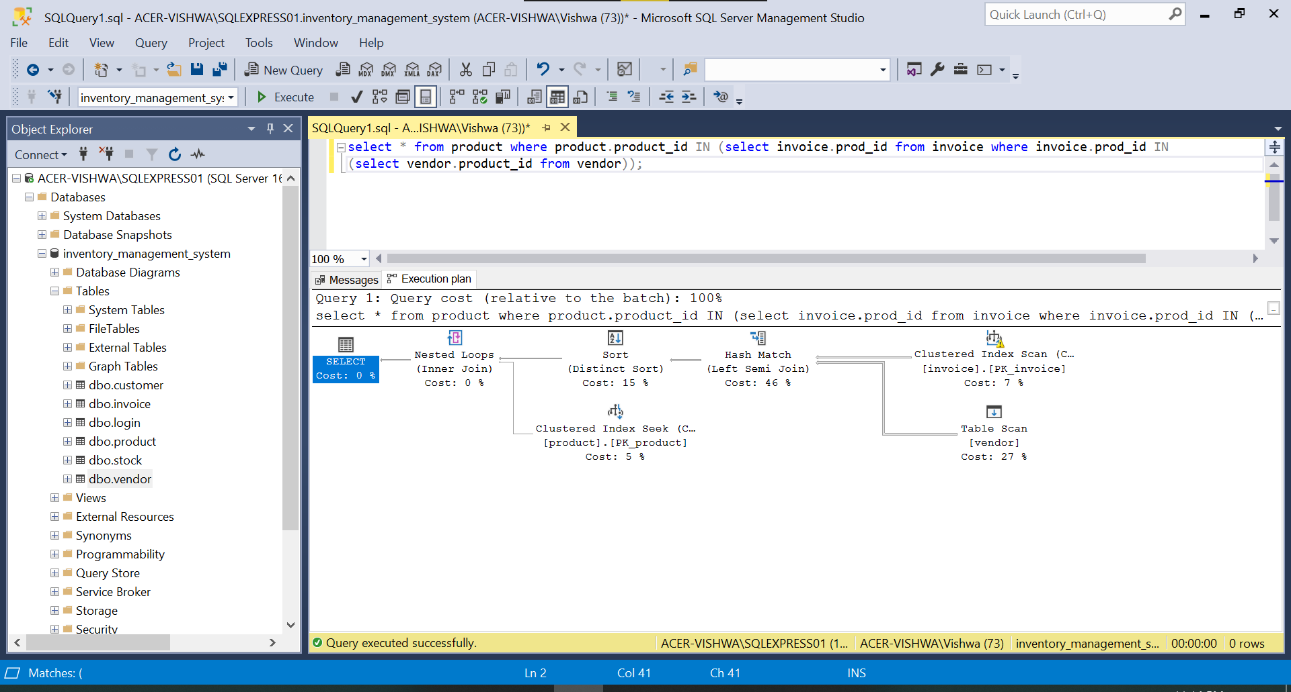

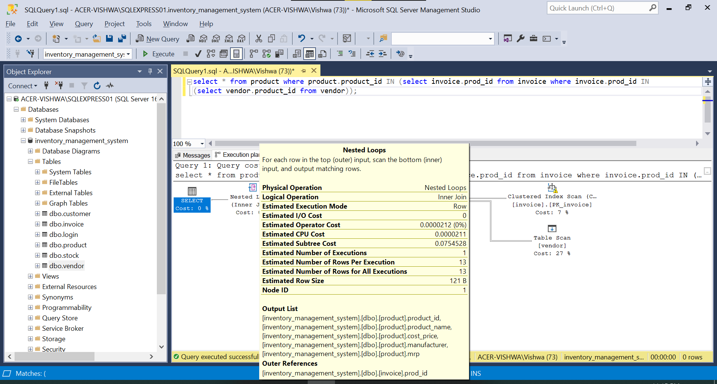

12. SUB QUERIES – product, vendor, invoice

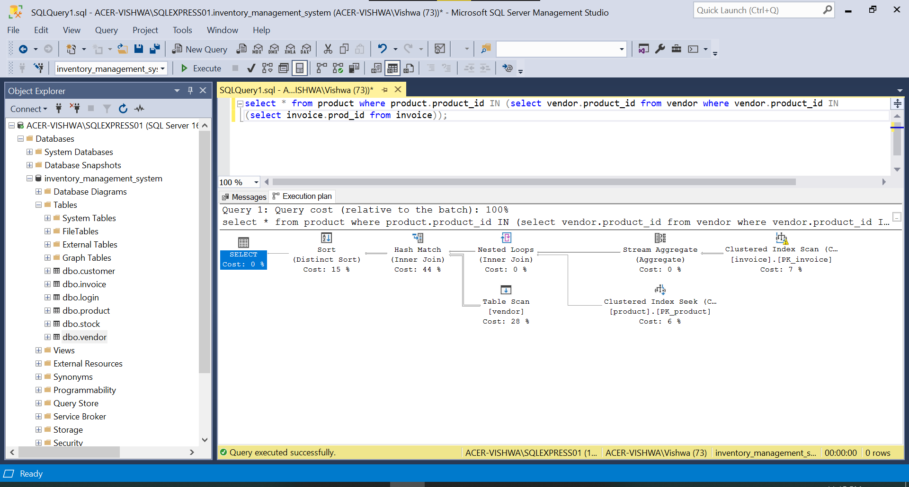

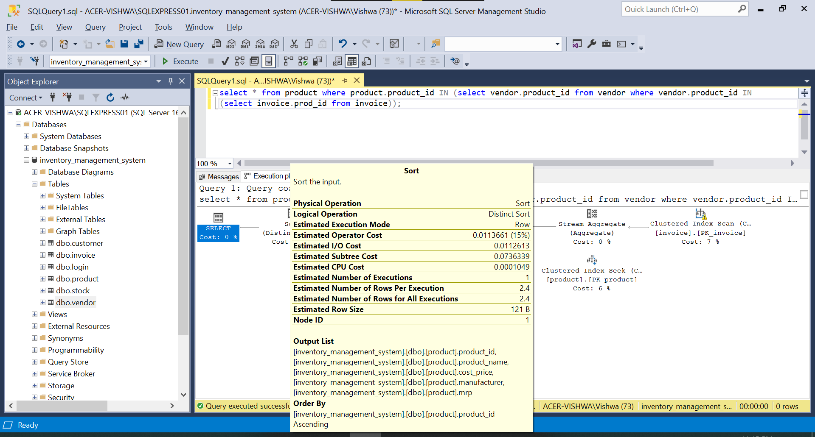

**Comparison of estimated subtree costs for different join operations and indexes:**

|  |  |
| --- | --- |
| **Operation** | **Estimated Subtree Cost** |
| 1. LEFT OUTER - invoice, stock, vendor | 0.0965849 |
| 1. LEFT OUTER (Order Changed) - vendor, invoice, stock | 0.0130995 |
| 1. RIGHT OUTER - vendor, invoice, stock | 0.10393 |
| 1. RIGHT OUTER (Order Changed) - invoice, stock, vendor | 0.0989511 |
| 1. SUB QUERIES - stock, invoice, vendor | 0.0754528 |
| 1. SUB QUERIES (Order Changed) - stock, vendor, invoice | 0.0785116 |
| 1. LEFT OUTER - invoice, product, vendor | 0.08988016 |
| 1. LEFT OUTER (Order Changed) - vendor, invoice, product | 0.0529401 |
| 1. RIGHT OUTER - vendor, invoice, product | 0.0293583 |
| 1. RIGHT OUTER (Order Changed) - invoice, product, vendor | 0.06455926 |
| 1. SUB QUERIES - product, invoice, vendor | 0.0754528 |
| 1. SUB QUERIES (Order Changed) - product, vendor, invoice | 0.0736339 |